

HND Web Development

**Designing and Developing an Interactive Product**

**HF3D 35**



Stage 2 –Creating, Developing & Deployment

LO2 – Create an Interactive Product

|  |  |
| --- | --- |
| Student Name | Lauchlyn downs |
| Class | Design & Developing an Interactive Product |
| Tutor | Drew Franks |
| Submission Date | 20th November 2020 |

Contents

*Report Instructions – Please remove before submitting* 3

Section 1 – Coding Techniques 4

Hand coding of original scripts 4

Use of variables and/or arrays 4

Implementation of control structures 4

Use of arithmetic and/or logical operators 4

Suitable file/asset naming conventions 4

Use of internal comments for code/scripts 4

APPENDICES 5

# Section 1 – Coding Techniques

## Hand coding of original scripts

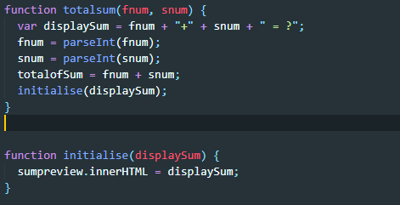

*Function that puts the numbers into simpler formats then calls a function passing the sum to be displayed to another function that changes the dom to show the current sum*

## Use of variables and/or arrays

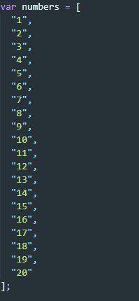

*Array to store the possible numbers on the sum*

## Implementation of control structures

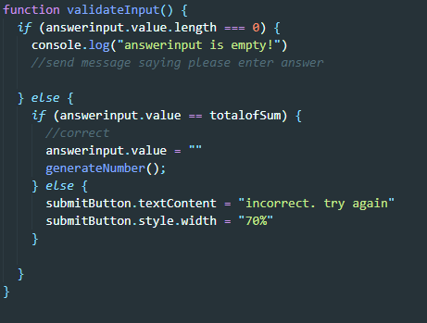

*Control structure that checks if the answer input is empty- if so do nothing, else if the answer is correct it calls a function that makes a new sum and empties the answer input field, if the answer is wrong it displays an incorrect message.*

## Use of arithmetic and/or logical operators

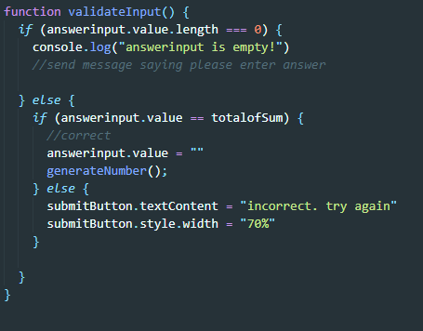

*I used === to check if the answer input was empty*

## Suitable file/asset naming conventions

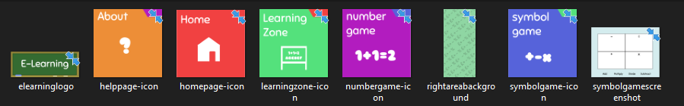

*File names are meaningful and contain no capital letters*

## Use of internal comments for code/scripts



Comment to tell the developer what the event listener does

# APPENDICES

**Test website: https://lauchlynwebsite.000webhostapp.com/index.html**